SQL Data Types
Data types are used to represent the nature of the data that can be stored in the database table. For example, in a particular column of a table, if we want to store a string type of data then we will have to declare a string data type of this column.
Data types mainly classified into three categories for every database.
- String Data types
- Numeric Data types
- Date and time Data types
CHAR(Size) | It is used to specify a fixed length string that can contain numbers, letters, and special characters. Its size can be 0 to 255 characters. Default is 1.
VARCHAR(Size) | It is used to specify a variable length string that can contain numbers, letters, and special characters. Its size can be from 0 to 65535 characters.
BINARY(Size) | It is equal to CHAR() but stores binary byte strings. Its size parameter specifies the column length in the bytes. Default is 1.
VARBINARY(Size) | It is equal to VARCHAR() but stores binary byte strings. Its size parameter specifies the maximum column length in bytes.
TEXT(Size) | It holds a string that can contain a maximum length of 255 characters.
TINYTEXT | It holds a string with a maximum length of 255 characters.
MEDIUMTEXT | It holds a string with a maximum length of 16,777,215.
LONGTEXT | It holds a string with a maximum length of 4,294,967,295 characters.
BLOB(size) | It is used for BLOBs (Binary Large Objects). It can hold up to 65,535 bytes.

MySQL Numeric Data Types
BIT(Size) | It is used for a bit-value type. The number of bits per value is specified in size. Its size can be 1 to 64. The default value is 1.
INT(size) | It is used for the integer value. Its signed range varies from -2147483648 to 2147483647 and unsigned range varies from 0 to 4294967295. The size parameter specifies the max display width that is 255.
INTEGER(size) | It is equal to INT(size).
FLOAT(size, d) | It is used to specify a floating point number. Its size parameter specifies the total number of digits. The number of digits after the decimal point is specified by d parameter.
FLOAT(p) | It is used to specify a floating point number. MySQL used p parameter to determine whether to use FLOAT or DOUBLE. If p is between 0 to24, the data type becomes FLOAT (). If p is from 25 to 53, the data type becomes DOUBLE().
DOUBLE(size, d) | It is a normal size floating point number. Its size parameter specifies the total number of digits. The number of digits after the decimal is specified by d parameter.
DECIMAL(size, d) | It is used to specify a fixed point number. Its size parameter specifies the total number of digits. The number of digits after the decimal parameter is specified by d parameter. The maximum value for the size is 65, and the default value is 10. The maximum value for d is 30, and the default value is 0.
DEC(size, d) | It is equal to DECIMAL(size, d).
BOOL | It is used to specify Boolean values true and false. Zero is considered as false, and nonzero values are considered as true.

MySQL Date and Time Data Types
DATE | It is used to specify date format YYYY-MM-DD. Its supported range is from '1000-01-01' to '9999-12-31'.
DATETIME(fsp) | It is used to specify date and time combination. Its format is YYYY-MM-DD hh:mm:ss. Its supported range is from '1000-01-01 00:00:00' to 9999-12-31 23:59:59'.
TIMESTAMP(fsp) | It is used to specify the timestamp. Its value is stored as the number of seconds since the Unix epoch('1970-01-01 00:00:00' UTC). Its format is YYYY-MM-DD hh:mm:ss. Its supported range is from '1970-01-01 00:00:01' UTC to '2038-01-09 03:14:07' UTC.
TIME(fsp) | It is used to specify the time format. Its format is hh:mm:ss. Its supported range is from '-838:59:59' to '838:59:59'
YEAR | It is used to specify a year in four-digit format. Values allowed in four digit format from 1901 to 2155, and 0000.

SQL Server Data Types
SQL Server String Data Type
char(n) | It is a fixed width character string data type. Its size can be up to 8000 characters.
varchar(n) | It is a variable width character string data type. Its size can be up to 8000 characters.
varchar(max) | It is a variable width character string data types. Its size can be up to 1,073,741,824 characters.
text | It is a variable width character string data type. Its size can be up to 2GB of text data.
nchar | It is a fixed width Unicode string data type. Its size can be up to 4000 characters.
nvarchar | It is a variable width Unicode string data type. Its size can be up to 4000 characters.
ntext | It is a variable width Unicode string data type. Its size can be up to 2GB of text data.
binary(n) | It is a fixed width Binary string data type. Its size can be up to 8000 bytes.
varbinary | It is a variable width Binary string data type. Its size can be up to 8000 bytes.
image | It is also a variable width Binary string data type. Its size can be up to 2GB.

SQL Server Numeric Data Types
bit | It is an integer that can be 0, 1 or null.
tinyint | It allows whole numbers from 0 to 255.
Smallint | It allows whole numbers between -32,768 and 32,767.
Int | It allows whole numbers between -2,147,483,648 and 2,147,483,647.
bigint | It allows whole numbers between -9,223,372,036,854,775,808 and 9,223,372,036,854,775,807.
float(n) | It is used to specify floating precision number data from -1.79E+308 to 1.79E+308. The n parameter indicates whether the field should hold the 4 or 8 bytes. Default value of n is 53.
real | It is a floating precision number data from -3.40E+38 to 3.40E+38.
money | It is used to specify monetary data from -922,337,233,685,477.5808 to 922,337,203,685,477.5807.

SQL Server Date and Time Data Type
datetime | It is used to specify date and time combination. It supports range from January 1, 1753, to December 31, 9999 with an accuracy of 3.33 milliseconds.
datetime2 | It is used to specify date and time combination. It supports range from January 1, 0001 to December 31, 9999 with an accuracy of 100 nanoseconds
date | It is used to store date only. It supports range from January 1, 0001 to December 31, 9999
time | It stores time only to an accuracy of 100 nanoseconds
timestamp | It stores a unique number when a new row gets created or modified. The time stamp value is based upon an internal clock and does not correspond to real time. Each table may contain only one-time stamp variable.

SQL Server Other Data Types
Sql_variant | It is used for various data types except for text, timestamp, and ntext. It stores up to 8000 bytes of data.
XML | It stores XML formatted data. Maximum 2GB.
cursor | It stores a reference to a cursor used for database operations.

Creation of Table Without Constarints:
create database viyas;
use viyas;
Creation of Table
create table cars(sno int, name varchar(20));
describe cars;
insert into cars values(2,'Chevrolet'),(3,'Dodge'),(4,'Hennessey Venom');
select * from cars;
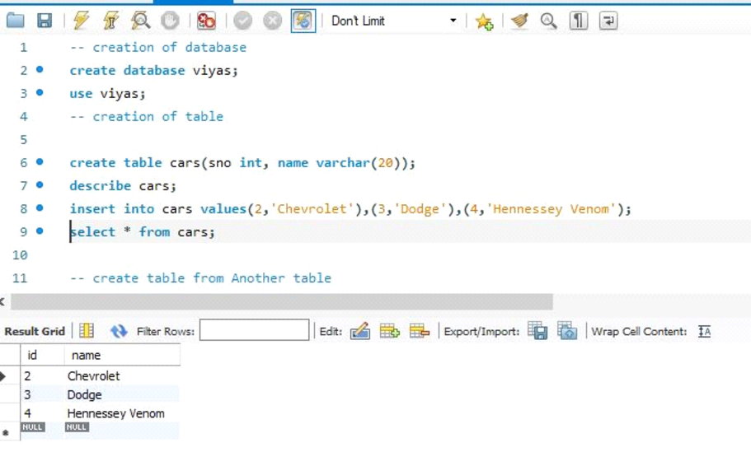
Create table from Another table
create table four_wheelers(select * from cars);
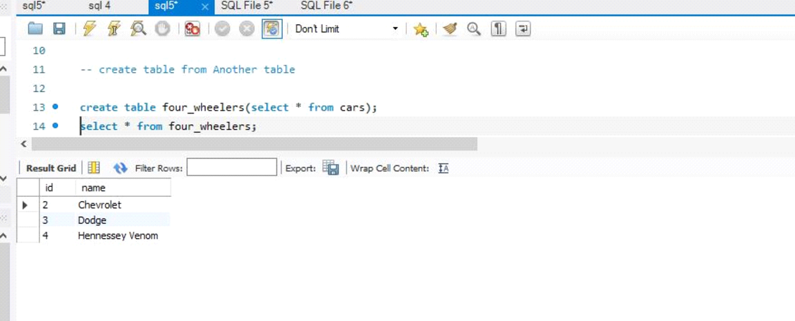
Creating Table With AUTO_INCREMENT Constraint :
Note: Autoincrement increments the column value automatically, initaially it assigns value 1
create table stocks(sno int primary key auto_increment , sname varchar(30));
describe stocks;
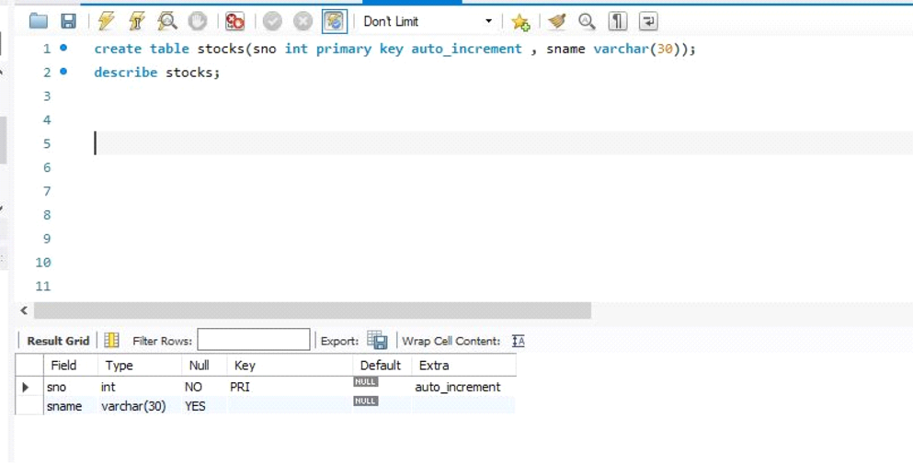

insert into stocks(sname) values('Eclairs'),('Oreo'),('Kitkat');
select * from stocks;
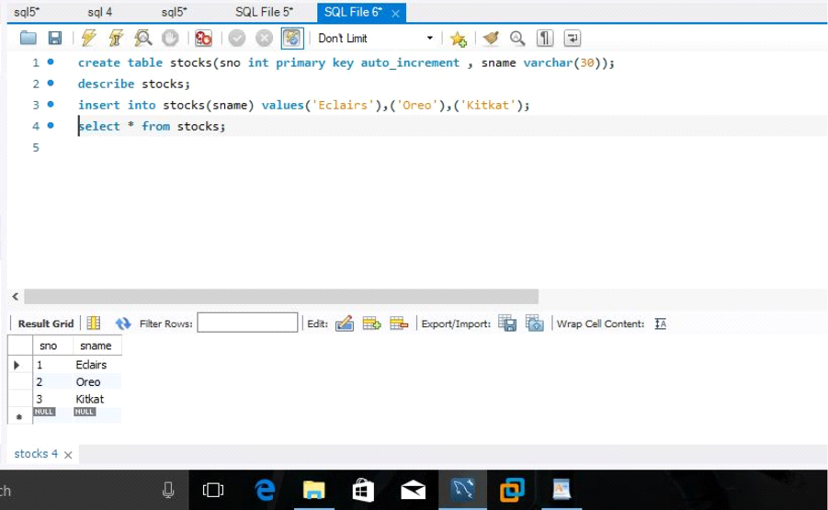

Check constraint
Create table Persons(id int not null,name varchar(45) not null,age int not null check(age>=18));
insert into Persons(id,name,age) values(1,'smriti',22),(2,'hema',35),(3,'amit',40);
insert into Persons(id,name,age) values(1,'rahul',13);
select*from Persons;
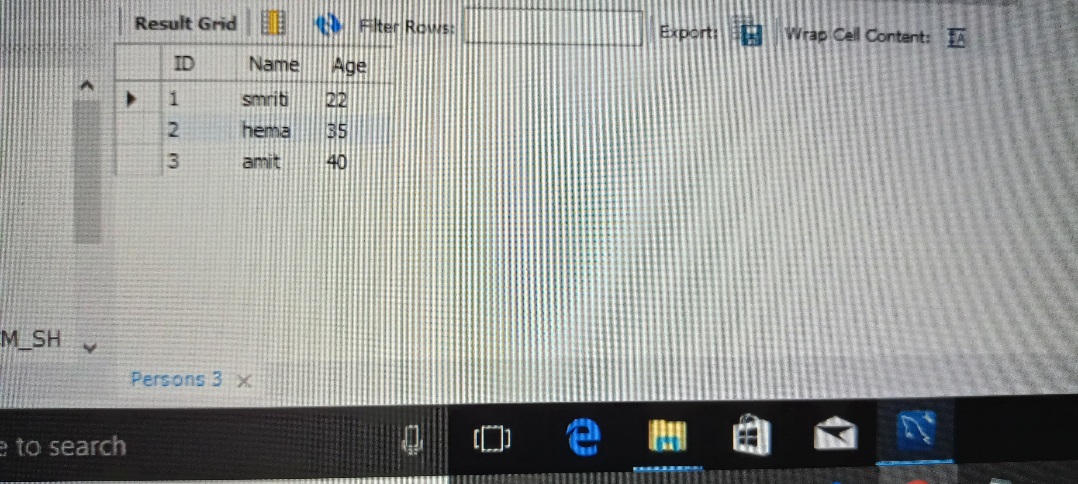
Default constraint
Create table places(id int not null,name varchar(30) not null,age int,city varchar(20)
default 'mumbai');
insert into places(id,name,age,city)
values(1,'shristi','22,'jharkhand'),(2,'neha',21,'Delhi'),(3,'Sana',35,'kolkata');
insert into places(id,name,age)
values(1,'sneha',36);
select * from tables;

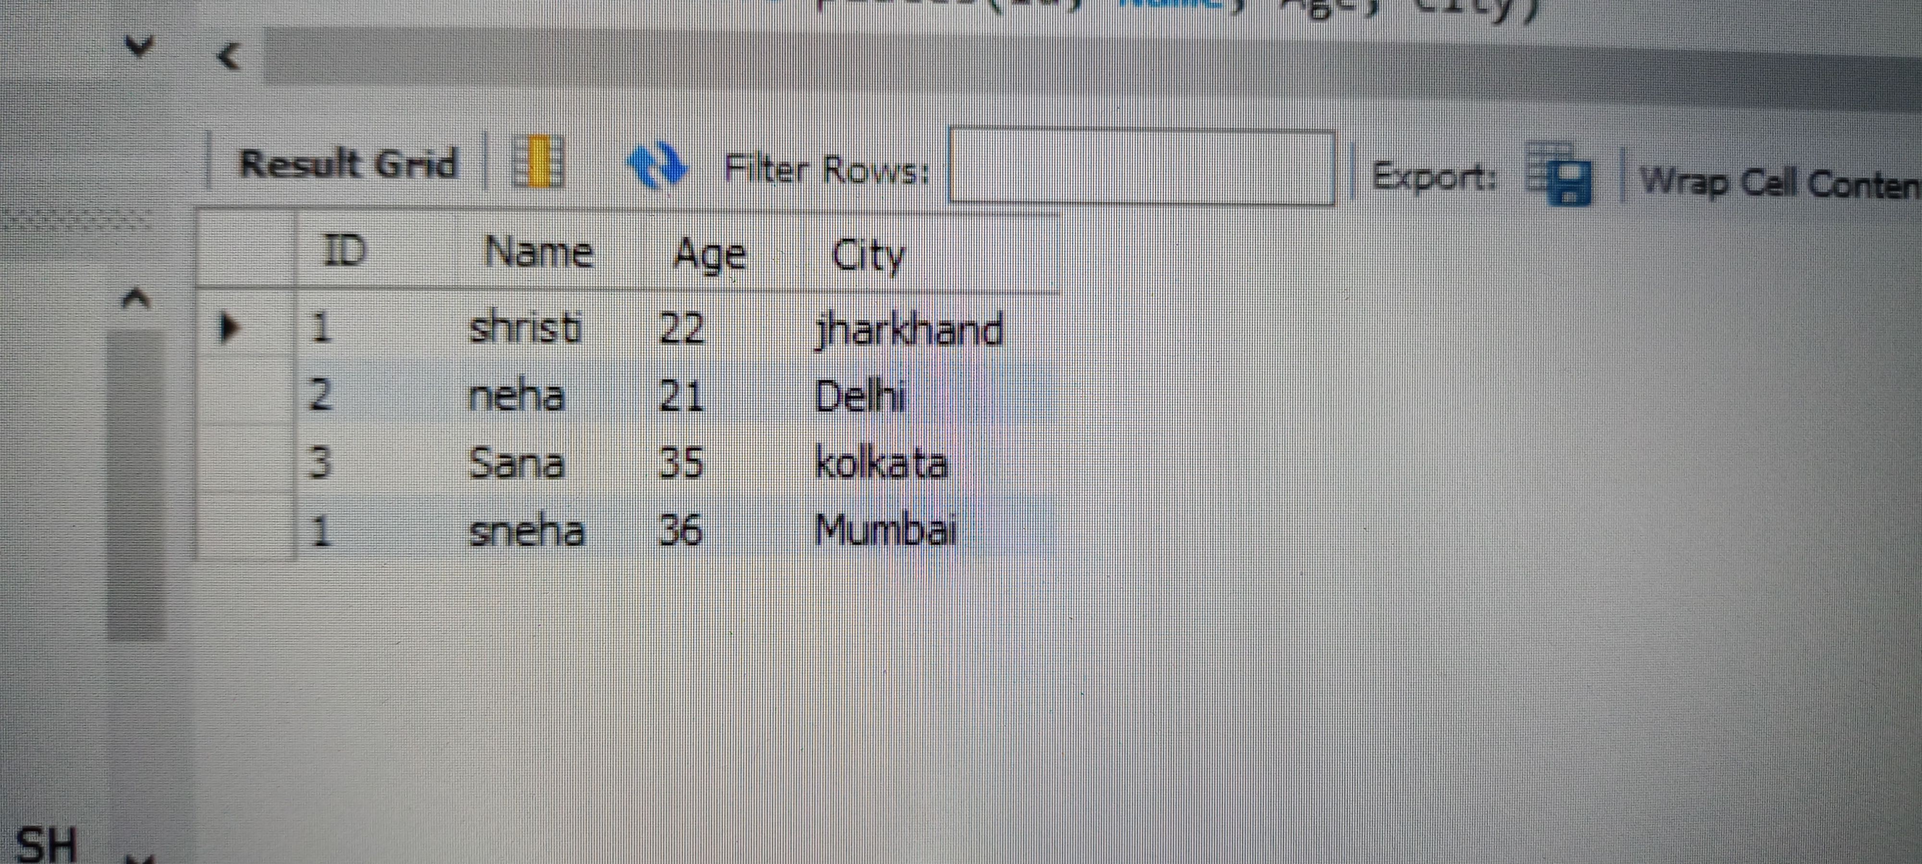
NOT NULL Constraint :
create database tasmiya;

use tasmiya;

create table customer1 ( cid int primary key,cname varchar(30) not null,caddress varchar(20) default 'bangalore',cphone int not null);

desc customer;

drop table customer;

insert into customer1 values(1,"tasmiya","ckm");

insert into customer1 (cid,cname,cphone) values(2,"priya",4567);

select * from customer1;

truncate customer1;

drop table customer1;

UNIQUE CONSTRAINT

The UNIQUE constraint creates an index such that, all values in the index column must be unique. An error occurs when any body tries to add a new row with a key value that already exists in that row.

CREATE TABLE Persons (
ID int NOT NULL,
LastName varchar(255) NOT NULL,
FirstName varchar(255),
Age int,
UNIQUE (ID)
);

UNIQUE Constraint on ALTER TABLE
To create a UNIQUE constraint on the "ID" column when the table is already created, use the following SQL:

ALTER TABLE Persons
ADD UNIQUE (ID);
PRIMARY KEY
The PRIMARY KEY constraint uniquely identifies each record in a table.
Primary keys must contain UNIQUE values, and cannot contain NULL values.
A table can have only ONE primary key; and in the table, this primary key can consist of single or multiple columns (fields).
The following SQL creates a PRIMARY KEY on the "ID" column when the "Persons" table is created:
MySQL:
CREATE TABLE Persons (
ID int NOT NULL,
LastName varchar(255) NOT NULL,
FirstName varchar(255),
Age int,
PRIMARY KEY (ID)
SQL PRIMARY KEY on ALTER TABLE
To create a PRIMARY KEY constraint on the "ID" column when the table is already created, use the following SQL:
ALTER TABLE Persons
ADD PRIMARY KEY (ID);

To drop a PRIMARY KEY constraint, use the following SQL:
MySQL:
ALTER TABLE Persons
DROP PRIMARY KEY;

FOREIGN KEY
FOREIGN KEY constraint is used to prevent actions that would destroy links between tables.
A FOREIGN KEY is a field (or collection of fields) in one table, that refers to the PRIMARY KEY in another table.
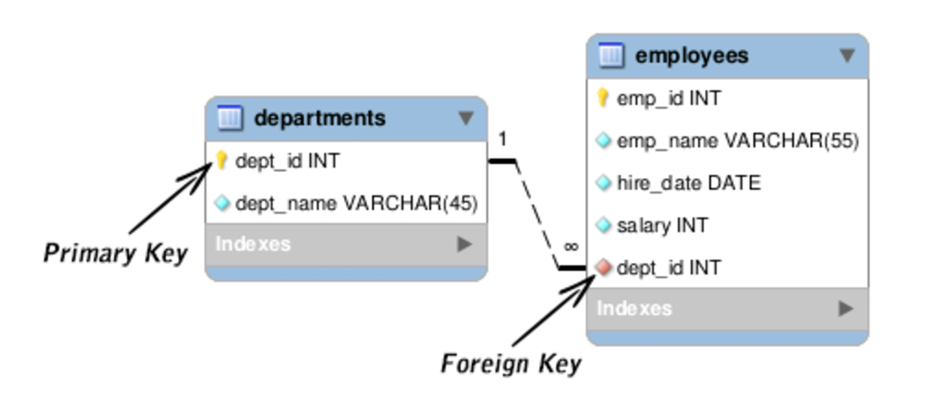

SQL FOREIGN KEY on CREATE TABLE
The following SQL creates a FOREIGN KEY on the "PersonID" column when the "Orders" table is created:
MySQL:
CREATE TABLE PERSON(
PersonID int NOT NULL,
primary key (PersonID)
);
CREATE TABLE Orders (
OrderID int NOT NULL,
OrderNumber int NOT NULL,
PersonID int,
PRIMARY KEY (OrderID),
FOREIGN KEY (PersonID) REFERENCES PERSON(PersonID)
);
Desc Orders;

SQL FOREIGN KEY on ALTER TABLE
To create a FOREIGN KEY constraint on the "PersonID" column when the "Orders" table is already created, use the following SQL:
ALTER TABLE Orders
ADD FOREIGN KEY (PersonID) REFERENCES Persons(PersonID);
To allow naming of a FOREIGN KEY constraint, and for defining a FOREIGN KEY constraint on multiple columns, use the following SQL syntax:
ALTER TABLE Orders

MySQL:
ALTER TABLE Orders
DROP FOREIGN KEY FK_PersonOrder;

ALTER TABLE Orders
DROP CONSTRAINT FK_PersonOrder;

